UNIVERSITY OF ULSTER
School of creative arts
DES-518 M2
Major Design Report – Reflective Study
John Kinsella
B00562925
Professor Paul Mc Kevitt
8th May 2012

Declaration
This work is entirely the work of the undersigned and has not been previously submitted, in whole or in part, as coursework for this or any course. Except for identified quotations and descriptions of the work of others, none of the following appears in any other work, published or unpublished, by any other person. I understand that any evidence to the contrary may be sufficient cause for the work to be awarded a mark of 'zero'

Signed ………………………………………….. Date …………………..

Abstract
The current economic climate has resulted in cutbacks in funding for charitable organisations such as Foyle Search and Rescue. This report showcases the vital role played by Foyle Search and Rescue and demonstrates how an organisation such as this is run, and also what it takes to be a volunteer with the service. The media chosen to best present this project was a short documentary film.
The project began with research into Search and Rescue Services across the globe. This provided an insight into how Search and Rescue organisations address advertising, marketing and awareness. Meetings and Interviews were set up initially to gain access and enable filming of the Foyle Search and Rescue crews. Nightly patrols were shadowed and footage recorded of what being a Search and Rescue volunteer entailed.
The final footage was then edited and cut to a time scale of six minutes and effects and colour correction were added using industry standard software such as Adobe After Effects Cs3, Adobe Premiere Cs3 and 3ds Studio Max. Sound was corrected using Adobe Sound Booth Cs3 and a music score was added courtesy of Gerard Gallagher from Acmetoonz. These elements came together to produce a short documentary film worthy of public viewing. The completed production can be used as a promotional and marketing tool to raise awareness amongst the general public and also as an educational resource for schools.

Table of Contents

1.0 Introduction 5
2.0 Background and Literature Review 6
2.1 Literature Review 6
2.2 Legal issues 7
2.3 Recommendations on phraseology 7
3.0 Aims and Objectives 8
4.0 Research 9
4.1 Primary Research 9
4.2 Secondary Research 9
5.0 Design and Production 10
5.1 Reflective Blog 10
5.2 Photography 11
5.3 Typography 11
5.4 Sound 11
5.5 Animation and Storyboards 11
5.6 Film Techniques 11
5.7 Concept 12
6.0 Documentary Narrative 13
6.1 Implementation of project 14
7.0 Evaluation 15
7.1 Project Results 16
8.0 Conclusion and Future Work 17
8.1 Conclusion 17
8.2 Future Work 17
9.0 References & Bibliography 18
10.0 Appendices 19
Appendix I – Agency Advertising Campaigns 19
Appendix II – Gantt Chart 20
Appendix III - Mind map 21
Appendix IV – PSNI Letter 22
Appendix V – Foyle Search and Rescue Boat 23
Appendix VI – Typographic Research 23
Appendix VII – Interview Setup at FSAR Boardroom 24
Appendix VIII – Thermal Camera 24
Appendix IX – Conceptual Work 25
Appendix X - HUD (heads up display) 25
Appendix XI – Shooting Schedule 26
Appendix XII – Head Camera 27
Appendix XIII – D3100 DSLR Camera 27
Appendix XIX - JVC Everio 28
Appendix XX – Volunteer Garvin Kerr Interview Footage Altered in After Effects 28
Appendix XXI - 3D Studio Max water tutorial 29

1.0 Introduction
This project showcases the vital role played by Foyle Search and Rescue.
The report sets out to demonstrate the role of a volunteer on a day to day basis and to highlight other positive aspects of this voluntary based charitable organisation. The aim of this project is to promote Foyle Search and Rescue through a short documentary film; particularly given the current economic climate and the shortage of funding for an organisation such as this. This documentary would give the viewer an insight into what it takes to run an organisation like Foyle Search and Rescue and show why it’s such an important service to the Derry community.
The documentary is for the general public and will be suitable to show in schools for most ages as there is no graphic or adult content. However, Foyle Search and Rescue will view the documentary in its entirety before it is broadcast. The final short documentary film piece will be packaged as an educational DVD.
This film could also be used as promotional material when applying for future funding, it would tick a lot of boxes in the funding application process.
According to Henderson (2012), “There is a difference between documentary and news interviews, when doing a documentary interview you want to ask less questions and let the people talk”. The aim is to make the viewer aware of the Volunteer’s dedication to ensuring the safety and wellbeing of the general public on the banks of the Foyle.
Prior to beginning the project, a meeting was set up with Foyle Search and Rescue, as it was necessary to discuss as any decisions on the health and safety of the staff and the film maker throughout the project with the management committee. A short pitch style presentation was made; this explained the initial aims of the project and what sort of access would be required from the service as a whole. This gave an early indication of what direction the project was going. Once the pitch was complete and the remit of the project made clear, the process of choosing a documentary style could begin.
The main objective of this report was to create a short documentary style film worthy of public viewing. Skills and knowledge gained from the two years on the BDes Design for Communication course would play a vital role in the making of this documentary. Software such as 3Ds Max and Adobe After Effects Cs3 would also be instrumental in the production of the film as it gave the opportunity to build environments and create special effects. Adobe Premiere Cs3 was also used as the editing tool for the overall finished production. The documentary would not be possible however were it not for the raw footage gathered or the cooperation of the volunteers over the course of the module. This footage was the foundation of the documentary and formed the basis of the narrative.

2.0 Background and Literature Review
Foyle Search and Rescue is a charity organisation based in Derry, Northern Ireland.
It was founded as a charity in 1993 and in its existence has adopted the role of ‘preserving human life’ in and around the banks of the River Foyle. It has come a long way since 1993 when all the volunteers had was some loose change in order to make an emergency call if a person was in danger.
It began in a tiny office in Queen Street, Derry which was kindly donated by Mr Kevin Clifford of Cityprint, a local printing firm in Derry. Mr. John Gilliland also kindly provided a purpose built shed that enabled the rescue boat to be launched which incidentally is still in use today. In 1995 the charity moved to a site located near the Craigavon Bridge. The site consisted of 3 portable cabins which provided basic facilities for the rescue team.
Today the current building is housed at Prehen, Derry and is part funded by the National Lottery, Peace & Reconciliation group, Department for Social Development DSD, and land donated by Derry City Council. The building has been designed to meet the requirements of the Search and Rescue team and consists of three floors dedicated to training, counselling, communication and administration. There is also room allocated for a large boatshed. A jetty was also provided by the PSNI (Police Service of Northern Ireland) community fund.
During the nineteen years Foyle Search and Rescue has been running, the intervention of its volunteers ‘whatever the weather’ has saved countless lives.
Their presence on the banks of the Foyle provides a great sense of comfort to the wider Derry community. They have a strategy in place that is proving to be an effective suicide prevention method that will continue to save lives by:
- Prevention, being present on night duty.
- Intervention, through personal and physical contact.

While gathering research for this project Foyle Search and Rescue were waiting on a release date and private screening of 360 Productions documentary on the rescue team. However the documentary hit an obstacle regarding ethics. A person at risk of suicide was prevented; the BBC stated that this intervention during the filming of the documentary might be conducive to another suicide attempt.
The intention of this project was to highlight other aspects of the work carried out by Foyle Search and Rescue and not to film people at risk of suicide.

2.1 Literature Review

“When preparing a research study employing mixed methods, the researcher needs to provide a justification for the use of this approach”. (Creswell, 2011, p. 7)
A look at advertising in all media platforms would be crucial to the final production of the documentary film. Ogilvy & Mather produced and advertising campaign for the National Sea Rescue Institute (NRSI Capetown). “The National Sea Rescue Institute is a non-profit organisation who helps save lives out at sea. Our brief was to conceptualise ads to salute these remarkable men and women. The campaign depicts the incredible lengths to which NSRI’s brave, unpaid volunteers will drop whatever they’re doing, at any time of day, to go off and save people’s lives. By showing them not just in treacherous seas, but sacrificing their personal time to do so, the volunteers take on a truly heroic aura”. (Darryl Dewet, 2010)
The intention of the project was to portray the volunteers in a vein similar to that of the National Sea Rescue Institute (NSRI), suggesting that they to give up their time to help save others. Mercer Bell created an interactive campaign in 2011 that was connected to a well-known social media website. The purpose of the campaign was fire prevention in the home. “As fast as fire-fighters are in attending a call, it's hard to be faster than fire. That's why Fire and Rescue NSW briefed us to launch a prevention campaign (see appendix I).
On their existing Facebook page, we created an online fire safety audit of their home. Those Super Ordinary heroes that did it would get their face projected on a huge bronze statue in the middle of Sydney, as a reward for their fire safety efforts. Messages were posted on their wall to spread the word amongst their friends, inspiring them to do the audit and get their face up there too”. (MercerBell, 2011)

This campaign inspired the direction of the Foyle Search and Rescue documentary as it motivated the viewer to get involved.

2.2 Legal issues

When discussing or reporting on suicide prevention; there are certain guidelines that the media must adhere to. After the first interview with Foyle Search and Rescue it became apparent that this topic was a sensitive area. It is fraught with moral, legal and ethical implications. Below are some of the phraseology or terms provided for the media.

2.3 Recommendations on phraseology

Use phrases like:
• A suicide.
• Death by suicide.
• Take one’s own life.
• A suicide attempt.
• A completed suicide.
• Person at risk of suicide.
• Help prevent suicide.

Avoid phrases like:
• A successful suicide attempt.
• An unsuccessful suicide attempt.
• Commit suicide
(Suicide is now decriminalised so it is better not to talk about ‘committing suicide’ but use ‘take one's life’, or ‘die by suicide’ instead)
• Suicide victim.
• Just a cry for help.
• Suicide-prone person.
• Stop the spread/epidemic of suicide.
• Suicide ‘tourist’. (Samaritans, 2008)

3.0 Aims and Objectives
The aim of this project was to promote awareness of Foyle Search and Rescue and the work they carry out. Foyle Search and Rescues advertising although extremely pro-active is quite limited in terms of design and communication. The fundamental reason for choosing this project was the ability to explore and generate interest in the organisation by means of a short film. With access to social media websites and broadcast channels, the video can reach an even wider audience. The end objectives are to enthuse and educate the public. Foyle Search and Rescue often visit local schools in order to educate children or young students about the dangers of water and the value of safety when near water or while sailing on a boat.
This short documentary film is purely observational. According to the Collaborative Documentary Workshop Porto (Burton, 2007), “Observational documentaries attempt to simply and spontaneously observe lived life with a minimum of intervention. Filmmakers who worked in this sub-genre often saw the poetic mode as too abstract and the expository mode as too didactic. The first observational documentaries date back to the 1960’s; the technological developments which made these possible include mobile lightweight cameras and portable sound recording equipment for synchronized sound”.

4.0 Research

4.1 Primary Research
The research for this project began initially with the Search and Rescue crew (Rescue 118) in Sligo, Ireland. As part of the second year modules on the BDes Design for Communication course, It was a requirement to produce a design piece based on the work carried out by the volunteers. It was awe inspiring to see first-hand the work carried out by these volunteers and the attention to detail. This created a thirst for knowledge and was a catalyst for my movement towards moving image and away from graphic design.
Initial research has drawn upon sources such as the internet, interviews, documentation, photographic and video research. Books will be sourced on how to gather research, how to create film and how to present a documentary style short film. As part of the research process; online tutorials relevant to the project will be explored and utilised. This will be an on-going process that will further enhance the final piece.
The project began with some initial web research, studying carefully how agencies worldwide tackle the topic of ‘search and rescue’. Organisations will be contacted in a similar environment and research will be collected on how they go about their duties. Search and Rescue organisations from other countries will be contacted as this will indicate if tasks in a similar environment are run in a different way. The knowledge and practical skills gathered over the course of the last two years and the use industry standard software will combine to present a short film worthy of public viewing.
In order to manage this project correctly and on time a Gantt chart was constructed to schedule tasks for the coming weeks. This proved to be a worthy tool to keep track of work and give a realistic time frame for projects to be carried out (see appendix II).
A mind map was also created, this enabled brainstorming of ideas that could be used for the project and helped free up time for other elements of design. It is also something that could be amended as the project progressed (see appendix III).

4.2 Secondary Research
This was an unfamiliar media that had been previously untried, in order to gain an advantage, learn techniques and gather some advice on filmmaking and sound and image, a series of audio interviews were conducted with people in the TV and Short Film Industry. Interviews took place with Professor Paul Moore, Head of School, University of Ulster, Magee, Des Henderson, Director, 360 Productions, Derry, Northern Ireland. Vincent Cunningham, Camera Man, Producer and Director, Northland Media.
People involved directly and indirectly with Foyle Search and Rescue were also interviewed. As the Foyle Search and Rescue team work in tandem with the PSNI (Police Service of Northern Ireland) it was the intention of the student to interview the liaison officer for the purposes of this project. This demonstrated the importance of the work carried out by Foyle Search and Rescue. Preparations were put in place to interview the PSNI (Police Service of Northern Ireland) (see appendix IV). A request has been made to the G-District Media Office with the Police Service of Northern Ireland.
This short documentary film would not be possible without referencing film makers, directors and authors of books on how to make short films. Interviews with people that have been involved in documentaries or short film were also very useful as it gave an invaluable insight into film making. Some crucial advice was given during these interviews, like how to prepare a person for interview. According to (Henderson, 2012) “What I think is important is that you go in and spend a bit of time without a camera, that way you know exactly what it is you need to film”. As this film was not intended to be filmed in a studio, the need for location shooting was paramount. According to (Harvey, 2008, p. 69) “Since filming in a studio might be a costly exercise, first time film makers particularly those not filming any drama scenes needing set construction, would be advised to utilise exterior and interior locations as much as possible, if not exclusively”.

5.0 Design and Production

5.1 Reflective Blog
As part of the design process for this module a reflective blog was required. This would indicate what was learned over the course of the module. The blog enabled me to analyse and evaluate work carried out for the project. The reflective blog was used as a platform to demonstrate techniques used on initial research, tutorials worked on in preparation for the final piece and as a building block for the final production. It was also useful as a feedback tool as lecturers in charge of the module could comment on the progress of the project. (Kinsella, 2012)

5.2 Photography
The use of photography in this project was crucial; it was the beginning of the visualisation process and created a scene almost instantly. Photography enables the filmmaker to create the foundation for a particular scene or scenes especially when shooting on location (see appendix V).

5.3 Typography
Typography is vital to the look and feel of the project; the wrong typography can make or break a production. The use of photography also helped in the use of typography as it built a picture of fonts used on signage, life preservers, boats and clothing. Once the font and typography were selected they were distributed carefully and selectively throughout the final piece (see appendix VI).

5.4 Sound
As most of the footage was recorded outdoors and on location; the built in microphone on the camera equipment could not always be relied upon, especially in a noisy environment. In order to capture sound correctly an external microphone was used to record voice and ambience.

5.5 Animation and Storyboards
The documentary began in the form of sketches and loosely demonstrated how the final piece would be created and displayed. In order to show this more vividly a storyboard will be created, it will detail each scene and what the purpose of the scene is within the final production. The storyboard will be in a diagrammatic form and in the style of FSAR (Foyle Search & Rescue).

5.6 Film Techniques
The project consisted mainly of video footage, photography and animation. It gave an accurate account of the work carried out by the Foyle Search and Rescue team. The intention was to make the viewer feel like they were involved in the action. The volunteers went on patrol on a Thursday, Friday and Saturday night from 10pm to 3am with a break around 12 am. The crew was split between the boat, the jeep and foot patrols. They were swapped over the course of the evening as this kept the volunteers alert to signs of people in distress or danger. Each team did a sweep through the zones allocated by the Emergency Response Coordinator. For example, the boat crew would sweep from the base to Craigavon Bridge then onto the Peace Bridge and down as far as their pontoon at the Derry City Council buildings on Strand Road, Derry. The crews kept in constant contact via hand held digital radios.
Each section of the team was shadowed and footage recorded with a head camera and a full HD 1080p camcorder, this gave a first person view point of a volunteer. Once the interviews of team leaders, founder members and employees were conducted, the location footage was then added to bring to life the narrative as told by the interviewees. Interviews were set up in a studio environment in the boardroom of the Foyle Search and Rescue base. “When talking to someone from Search and Rescue, you try to be there with them in their environment. What causes the tension is the actual environment you are operating in. Even when you are putting up lights and setting up cameras, at least they are in an environment they understand and are comfortable with”. (Moore, 2012)
To create a uniform distribution of colour throughout the film I used Adobe After Effects colour pre-set, this allowed me to setup the colour pre-set as an adjustment layer that could be edited to suit specific time requirements or scenes within the footage. Adobe After Effects and Adobe Premiere Pro were used to edit and cut the footage, apply colour correction, audio adjustment and apply special effects and additional graphics. While editing the film footage, there were a few factors that needed to be taken into account. This meant taking a disciplined approach in editing and removing any dull sections of film footage. According to (Harvey, 2008, p. 226) “The aim is to remove any laboured, muddled and not entirely relevant footage and footage clearly in the wrong place. When editing the final piece careful consideration will have to be given to whether people, places and events have been setup properly so that the viewer can follow the storyline without confusion. This will mean dropping any interviews that do not have any footage to illustrate the interview or bring it to life”. Photography was used to demonstrate and catalogue images pivotal to the design and implementation of this short documentary film, the images were then colour corrected in Adobe Photoshop to give an indication of the colour setting intended for the final piece. Parts of the footage were separated with different colour correction settings, for example an interview scene was given a different colour correction setting to a night patrol scene or a day scene. This allowed the viewer to distinguish areas of interest within the finished piece.
5.7 Concept
With the footage in place consideration could then be given to which title sequences, graphics and transitions will be used for the final piece. The majority of these sequences were created in Adobe After Effects but some graphics, transitions and title sequences were also created in Autodesk 3D Studio Max.
The crew used state of the art technology while out on patrol, the most recent of which was a thermal imaging camera that could detect body heat in the cold temperatures of the River Foyle (see appendix VIII). The initial sketches for the project outlined the need to use technology on screen (see appendix IX). The final piece demonstrated the use of this technology in a variety of ways, for example a steering compass for boats (see appendix 8.4). This provided the viewer with a sense of direction through the transition phases of the short documentary film by navigating to the direction of the next scene. As coordinates played a vital role in the work carried out by the volunteers, the film reflected this throughout with a HUD (heads up display) graphics and type animation over the top of the footage (see appendix X). Photography at the beginning of the research phase provided the foundation for this concept. Adobe Sound Booth was a fantastic editing tool for sound, especially for the HUD display as it needed to be tweaked to a high pitch to replicate computer sounds. The final production however had a professional sound track added by sound engineer Gerard Gallagher, Producer at Acmetoonz Recording, Belfast. As previously discussed the documentary took an observational point of view, so music was used as an alternative to a voiceover.
The transition phases of the documentary film were created using Autodesk 3D Studio Max, projects set throughout the two years of the BDes Design and Communication course proved invaluable as the techniques learned were applied. (see appendix 8.6).
6.0 Documentary Narrative
The short documentary film is observational and gave an accurate account of the duties carried out by the Foyle Search and Rescue team at Prehen, Derry.
After concept and storyboard phase had been created it was time to begin filming with a shooting plan (see appendix XI) this indicated who would be filmed for interview, what will be shot for film and where and when it will be shot. It also give an approximate time for shooting and whether the footage needed to be shot during the day or night.
It was decided at an early stage that the narrative of the movie would be driven by interviews of key members of staff at the search and rescue base. Paddy Wilson, Emergency Response Coordinator talked about how Foyle Search and Rescue originated, where it is at present and what plans are being made for the future of the voluntary based organisation. Sean Edwards, Shore Coordinator explained the duties of the volunteers and the process of recruitment of new volunteers and the training offered. Amy Coll, Administration and Funding, discussed the day to day running of the base and how funding was raised to provide equipment, running costs and the essential service carried out by the organisation.
While creating concepts for this short documentary film, it became apparent quite early on that the look and feel of this movie would be grainy and saturated with high contrast. The reason for this concept was to give the final piece an overall look of gritty realism. The footage recorded for the documentary was shot entirely in a raw HD format except for interviews which were studio lit. Stills from the footage were then used to plan a final storyboard. I served as a good indication to how the final piece might look. Using this format allows you to change sequences should a problem arise. Once completed, the process of elimination could begin. This meant finalising scenes and making notes for post-production. Although this film is factual and from an observational point of view, there will be a certain degree of artistic merit added. Any artistic additions will be added in post-production and will be in the style of search and rescue.

6.1 Implementation of project
With permission and access to duty nights granted with Foyle Search and Rescue, the next stage of the process could begin. Having pre-planned the scenes in the form of sketching and storyboards it was easy to indicate to the team what my intentions were regarding filming.
On the first night of filming a head camera was introduced to gather footage, this was to give the viewer a first person view point of what was going on while on patrol with the crew (see appendix XII). After watching the first patrol footage, it became apparent that the head camera deployed just wasn’t strong enough in low light situations. A much more versatile camera had to be put in place. One that could work well in low light and that could be attached to a tripod for steady shooting (see appendix XIII). The HD recording function on the Nikon D3100 DSLR, proved to be great in most situations but due to the size of the camera it was a struggle to keep it steady especially on patrol with the boat crew, even with the use of a tripod. The only solution was to purchase a hand held full HD camcorder. After some research into the specification that was required for the project, it was decided that the JVC Everio full HD camcorder (see appendix XIX) worked best for specification and budget. With a super Lolux light setting, stabiliser, LED light and 40x optical zoom, this particular camcorder addressed the demands of night filming and motion capture. One of the key elements to Foyle Search and Rescue is safety; safety is paramount both to the crew and civilians. This also applies to anyone who might be an observer or filming. The fact a tripod was on board posed as a safety risk, as of then, only the head of the tripod was used for shooting. With the equipment in place, the next step was to start shooting. Before this could begin a check list needed to be drawn up for patrol filming. Below is a list of equipment used while filming with Foyle Search and Rescue on patrol:
- Full HD Camcorder
- Tripod
- Digital voice recorder
- LED Head Torch
- Spare Battery for Camcorder
- High Visual Jacket
- Lifejacket (while on boat patrol)
Filming continued over three months, spending up to three hours with the crew per patrol night getting to grips with the footage required for the final project. Training nights were also recorded as it let the viewer see first-hand just what goes into training a volunteer. Three cameras were used for the final production and all give their own unique perspective to the story. Realistically not all footage was used, only the parts that relate to my narrative.

7.0 Evaluation

Considering that film was an untried media format for myself, I was satisfied that my camera work got stronger as the project progressed. This was due mainly to trials setup at home and on location. The objective of my report was to examine the vital role played by Foyle Search and Rescue within the Derry community. The primary aim of the project was to make a short documentary style film on Foyle Search and Rescue.
Much planning and preparation had to be carried out in advance including meetings, interviews, introductions, patrols, correspondence and filming. This was all made possible by using time management skills and tools. The use of a Gantt chart from Microsoft Project was invaluable as it allowed the project to flow and gave me the time to plan and prepare for vital stages of the of the documentary. The tutorials covered during the course of my two years in the BDes Design for Communication degree were sometimes challenging but gave me the confidence to pitch and share my vision for the final production to my peers and staff at Foyle Search and Rescue. A lot of this project was about thinking on your feet as the patrols were constantly on the move. Concepts were crucial as they allowed the team to see what direction the scenes were going.
Having completed the documentary, the process of evaluation could begin with a breakdown of results. The documentary was based on a narrative provided by founder members, staff and team leaders in Foyle Search and Rescue. Overall the project went according to the proposal set out in the initial brief. All aspects of learning acquired throughout the BDes Design for Communication course were utilised and incorporated into the final production.
The final production lasted the proposed six minutes although this time frame was altered after an interview with Des Henderson of 360 Productions. The original proposed length was ten minutes, but Des suggested six minutes after explaining his documentary on Foyle Search and Rescue used one hundred and fifty hours of footage to create only one hours viewing time.
The purpose of this was to showcase the vital role played by Foyle Search and Rescue. The fundamental objective was to positively portray the work carried out by this charitable organisation. Three important sections of the organisation were analysed in-depth; how the organisation was founded, how the work was carried out by the volunteers and how funding is provided for the organisation on a day to day basis. To give the film a sense of reality a camera was introduced during training and patrol nights. This footage would lend itself to the narrative created by founder members, staff and team leaders during recorded interviews. Research into how other organisations carried out their work was vital to the Foyle Search and Rescue film. Research was received from the United States Coastguard after correspondence via e-mail. The press pack from the organisation proved invaluable as it contained an insight into how the coastguard was run, their advertising strategies and demonstrated in detail how interviews were carried out. Although the United States Coastguard operates on a much larger scale than Foyle Search and Rescue, it nonetheless helped in a preparatory sense for the final production.

7.1 Project Results

In order to capture the footage properly, interviews were conducted with people from within the field of television and film making. This helped to ensure that interviews undertaken as part of the project were carried out correctly and that the documentary footage was filmed with an unbiased approach.
Much of the learning and skills I developed throughout the BDes Design for Communication course were employed to enhance the final production. I used industry standard software packages such as Autodesk 3Ds Max, Adobe After Effects Cs3, Adobe Premiere Cs3 and Adobe Sound Booth Cs3. These provided effect and information graphics to emphasise the narrative as explained by the volunteers (see appendix XX & XXI).
In conclusion, the completed film projected the positive message set out by Foyle Search and Rescue - ‘the preservation of human life’ in and around the banks of the River Foyle. The final production was packaged as an educational DVD for Foyle Search and Rescue to use to promote education through awareness.
To be sure the project was going in the right direction, the film footage and scene plans were discussed at length with Paddy Wilson and Sean Edwards of Foyle Search and Rescue. This allowed for any shortcomings that may have arisen from the content that was filmed during the course of the module.
Overall, the project was an amazing learning curve. It presented challenges throughout the duration of the module, one of which was cost. In order to portray Foyle Search and Rescue professionally, equipment had to be upgraded constantly as the footage was not to an adequate standard at the beginning of the project. Cameras were upgraded; memory was increased to allocate filming and lighting was purchased to insure the best possible outcome during filming.

8.0 Conclusion and Future Work

8.1 Conclusion

It is important to note that Foyle Search and Rescue is a charity organisation run by volunteers who give up their spare time in order to provide a much needed service along the banks of the River Foyle. The interventions of these volunteers have saved hundreds of lives. The current economic climate we are living in has made things more difficult than ever for the rescue service to secure much needed funding as public funding has been slashed due to government cuts. The intention of the project and report was to promote awareness through education in the form of a short documentary film. This came about through initial meetings, presentations, going on patrol with the crews by boat, foot and jeep. On the patrols footage was gathered; this footage was the foundation for a narrative that was created by founder members and shore coordinators. They explained how the organisation came about, what it takes to run and what training is given to new and existing volunteers. The techniques used in this short documentary film were the result of two years hard work over the course of my degree. Through teaching and learning in my spare time I soon gathered a body of work which was applied to my final piece. The fundamental reason for this short documentary film was to raise awareness of a charity organisation. My aim was to create a short documentary film worthy of public viewing.
Working with Foyle Search and Rescue has been a great motivational tool. It has provided a platform to communicate ideas through a broad spectrum of design. The Design for Communication course has been a fantastic process for learning. Originally a graphic designer, the teaching and projects carried out over the course of the two years have now enabled this designer to branch out into the world of motion graphics 3D and Moving Image.

8.2 Future Work

Now that the project and report are complete an opportunity to carry this module concept across a whole media campaign could be developed. A print campaign could be deployed across the bridges in Derry to act as a possible deterrent for people considering a suicide attempt. An email shot could also be created using a technique to transfer a photograph onto wood using a gel medium and mod podge glue. This could be utilised by creating a hard hitting advert campaign or by using statistics to show how Foyle Search and Rescue have saved lives on the banks of the River Foyle. Foyle Search and Rescue are welcoming Search and Rescue organisations from across the world in June of this year as part of their own awareness campaign. They are also planning to embark on their own advertising campaign by staging a live rescue from the Peace Bridge in Derry. A full scale rescue operation is planned and will require the help of the Rescue Helicopter at Rescue 118 in Sligo. Given more time the documentary could have been developed to include this visit and campaign. Fundraising is a key aspect to Foyle Search and Rescue, this can range from door to door collections, donations, bag packing in supermarkets and staged charity events. Unfortunately these events are happening outside of my project timescale. Events like these could have been included in the documentary as they demonstrate the lengths the volunteers go to to keep Foyle Search and Rescue running and providing an essential service to the people of Derry.

9.0 References & Bibliography

Burton, A. (2007, November 16). 6 Types of Documentary. Retrieved April 10, 2012, from http://collaborativedocumentary.wordpress.com: http://collaborativedocumentary.wordpress.com/6-types-of-documentary/
Creswell, P. C. (2011). Designing and Conducting Mixed Methods Research. Thousand Oaks, California: Sage Publications.
Darryl Dewet. (2010, May 10). NRSI-Always on call. Retrieved April 15, 2012, from http://darryldewet.com: http://darryldewet.com/ogilvy/our-work/nsri-always-on-call/
Harvey, B. (2008). How to make your own video or short film. Oxford: How to books.
Henderson, D. (2012, March 12). Documentary film maker. (J. Kinsella, Interviewer)
Kinsella, J. (2012, March 1). Reflective Blog. Retrieved November 3, 2009, from http://jk-bdesdesignvisualcommunication.blogspot.co.uk/: http://jk-bdesdesignvisualcommunication.blogspot.co.uk/
MercerBell. (2011, August 24th). Fire and Rescue. Retrieved March 12, 2012, from http://www.mercerbell.com.au: http://www.mercerbell.com.au/#!/1292/Fire &amp; Rescue
Moore, P. P. (2012, April 12). Documentary film making. (J. Kinsella, Interviewer)
Samaritans. (2008). Samaritans Media Guidelines UK 2008. Retrieved April 28, 2012, from Samaritans: http://www.samaritans.org/pdf/SamaritansMediaGuidelines-UK2008.pdf - Page 8.

10.0 Appendices

Appendix I – Agency Advertising Campaigns

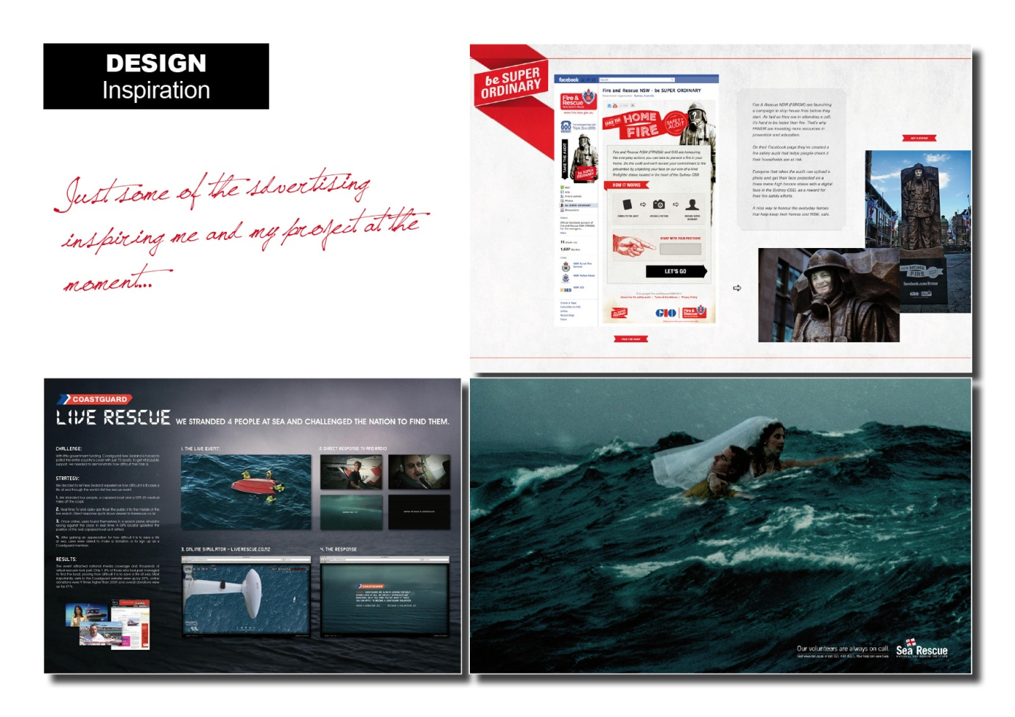

Appendix II – Gantt Chart
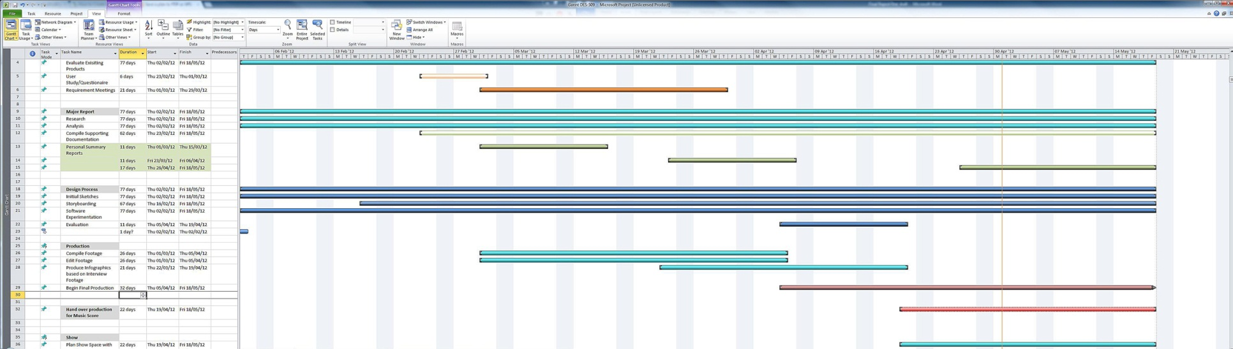

Appendix III - Mind map

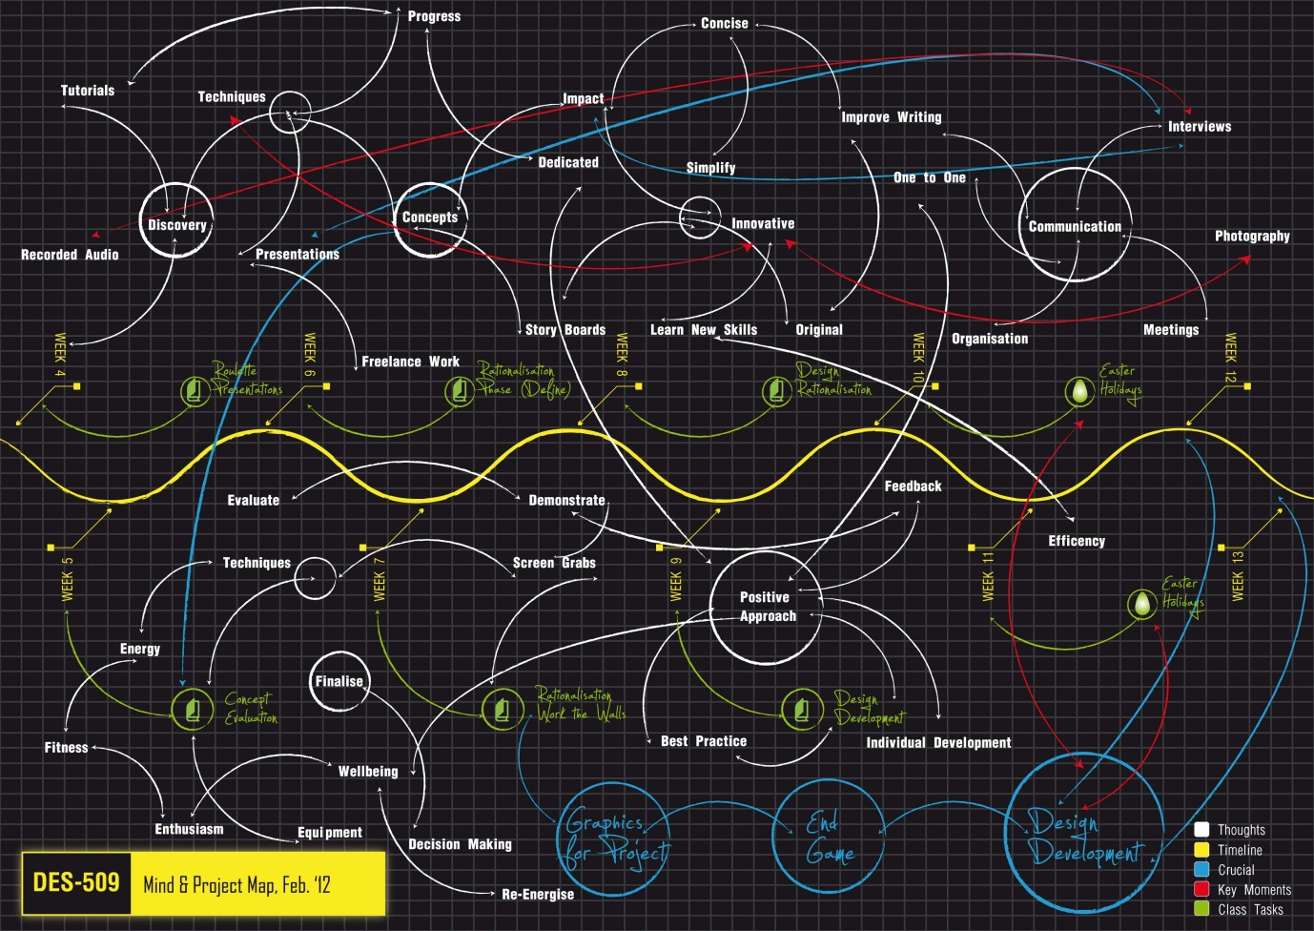

Appendix IV – PSNI Letter

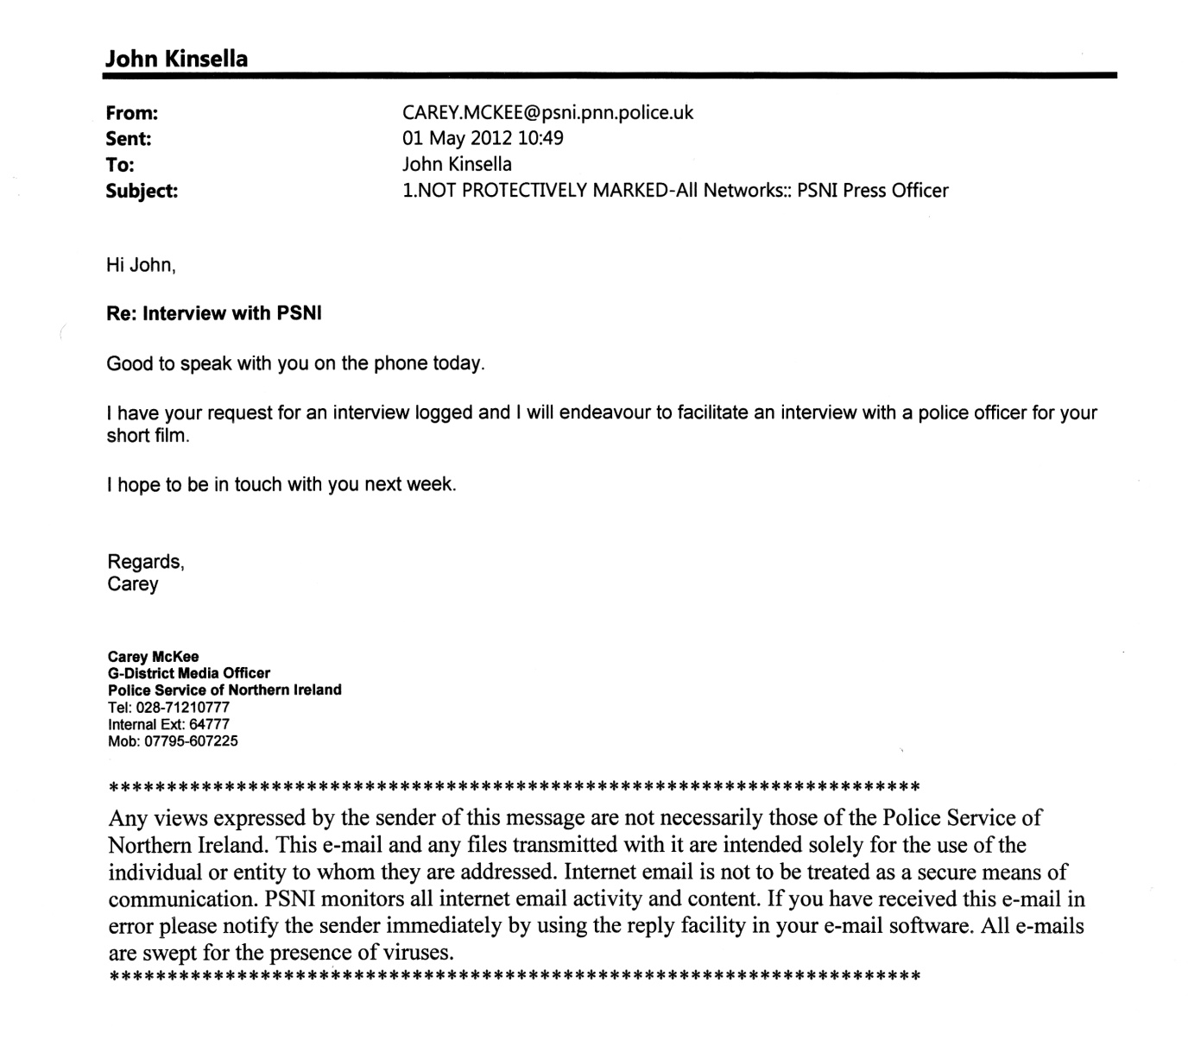

Appendix V – Foyle Search and Rescue Boat

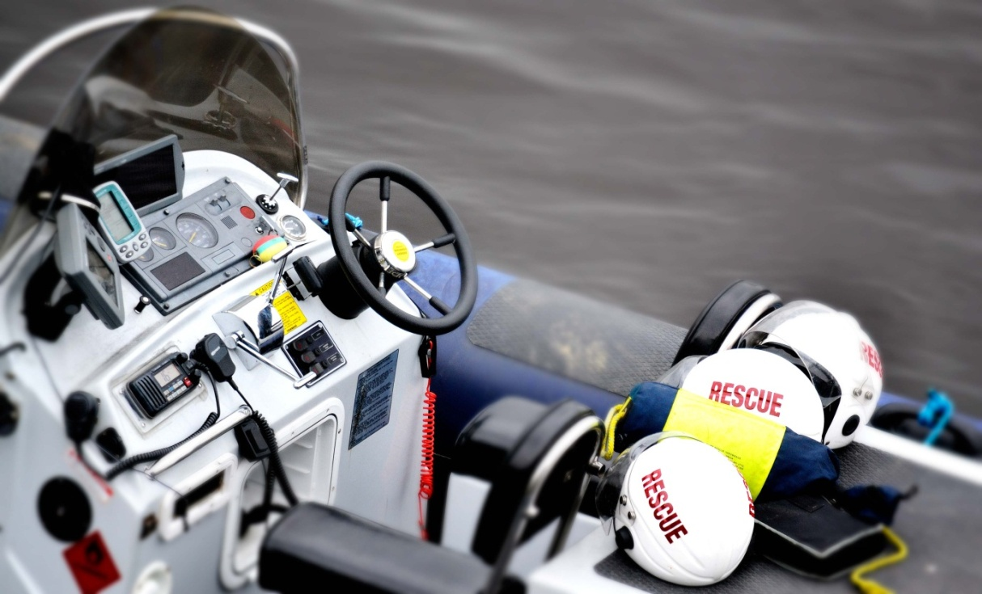

Appendix VI – Typographic Research

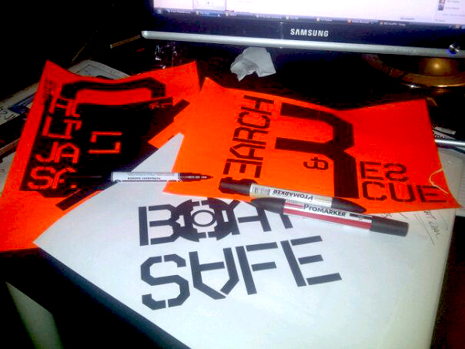

Appendix VII – Interview Setup at FSAR Boardroom

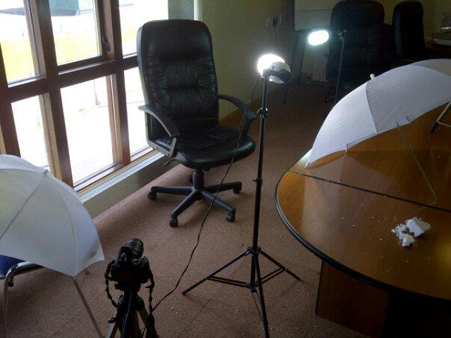

Appendix VIII – Thermal Camera
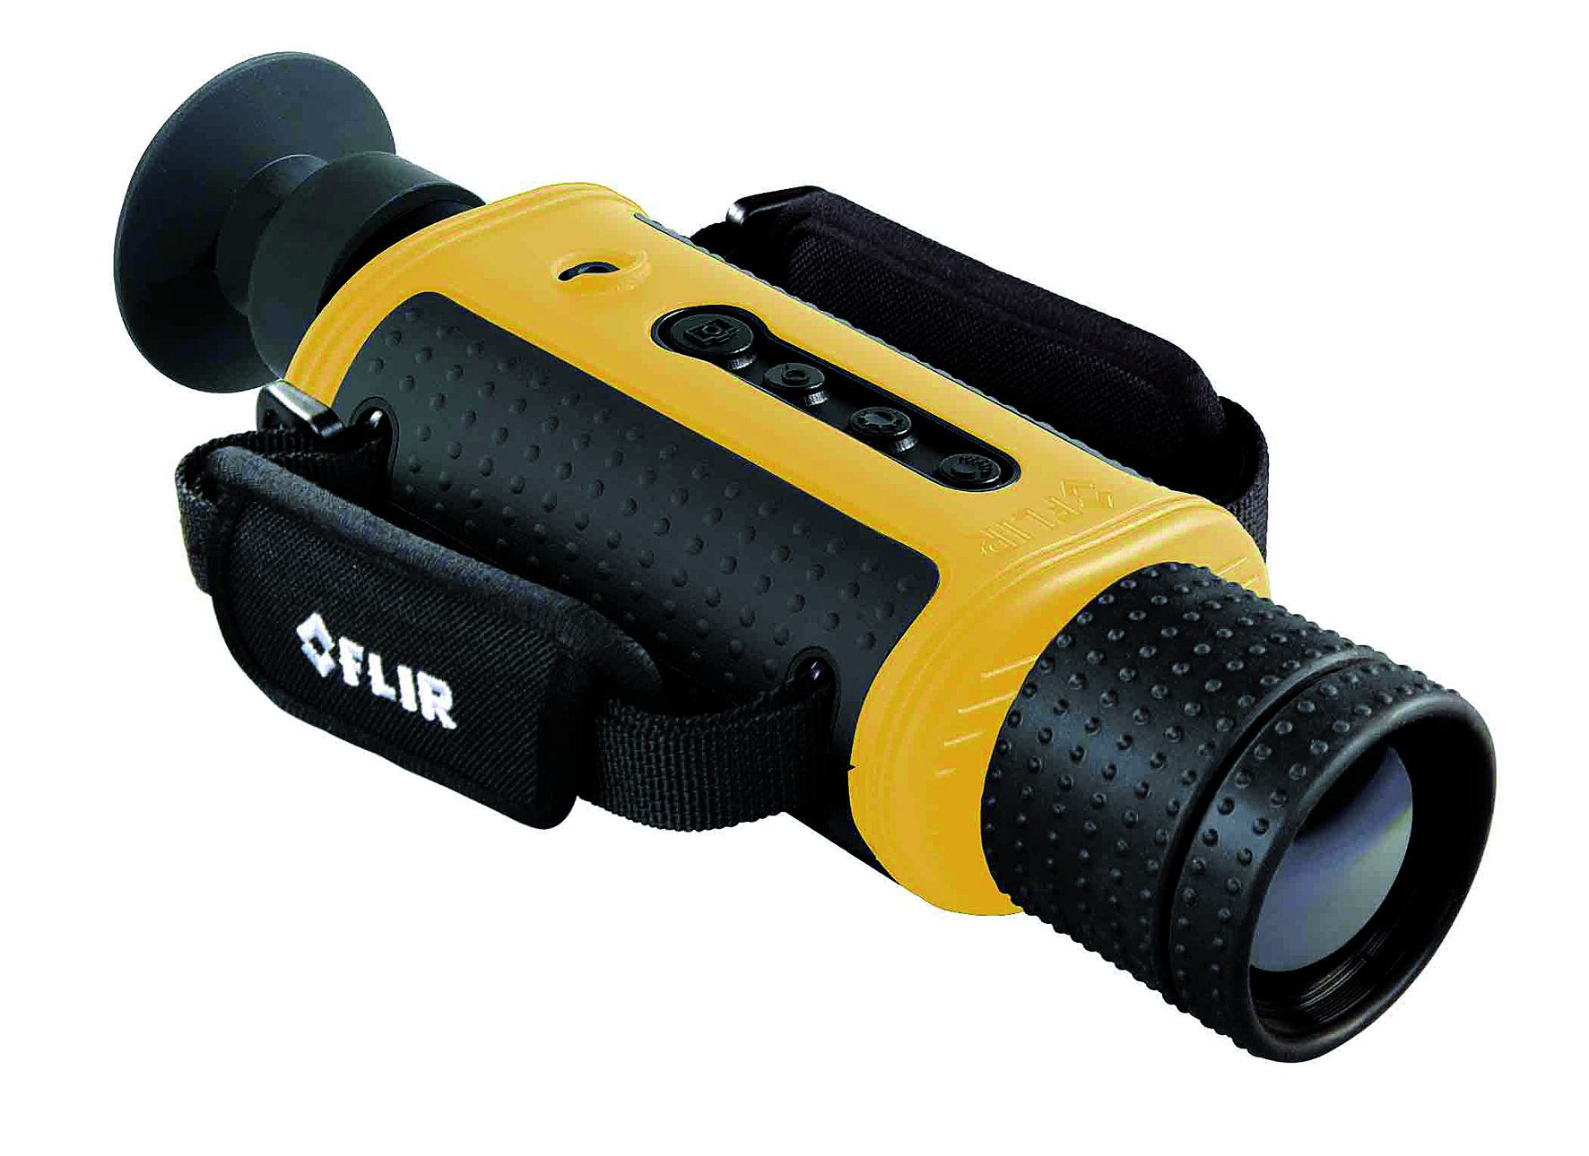

Appendix IX – Conceptual Work
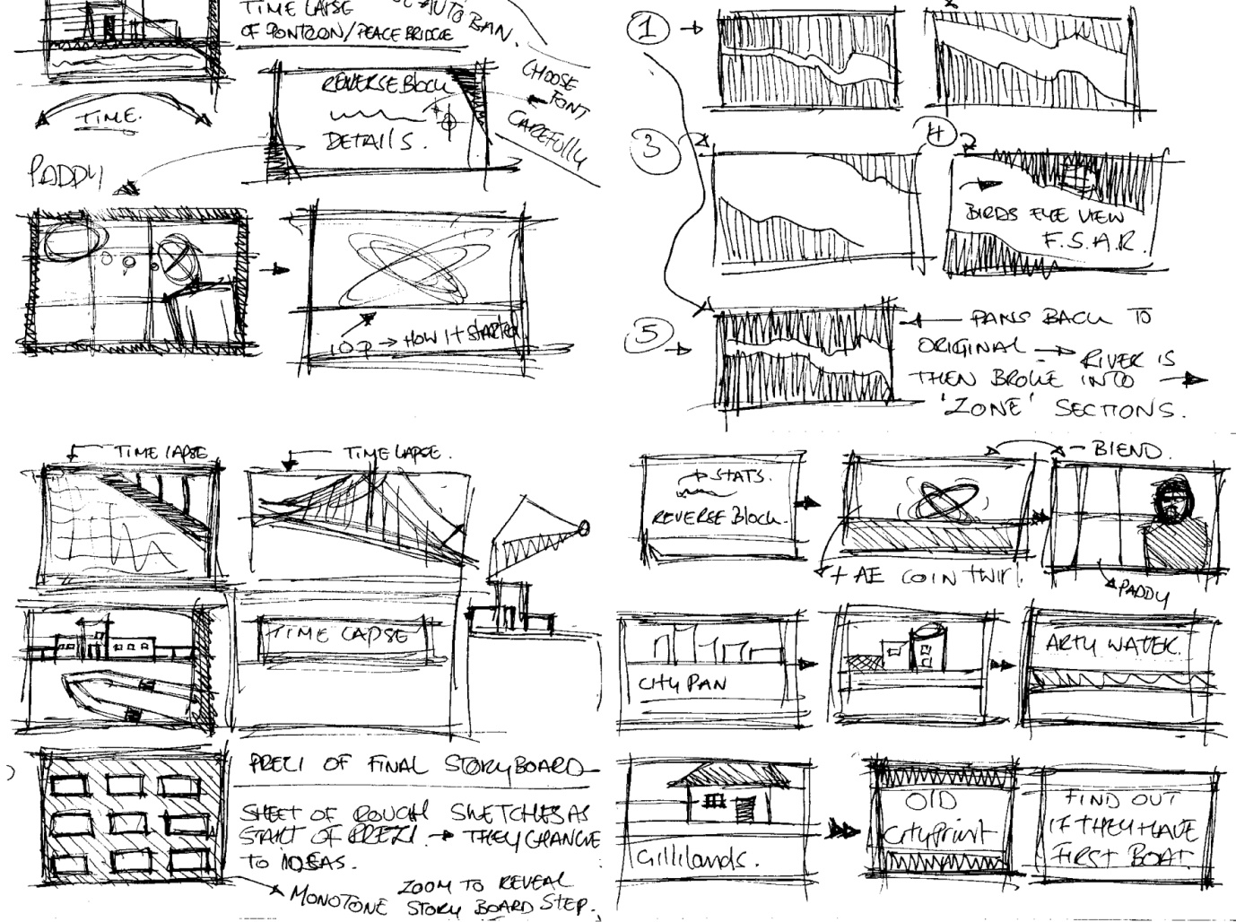

Appendix X - HUD (heads up display)
Hud graphic examples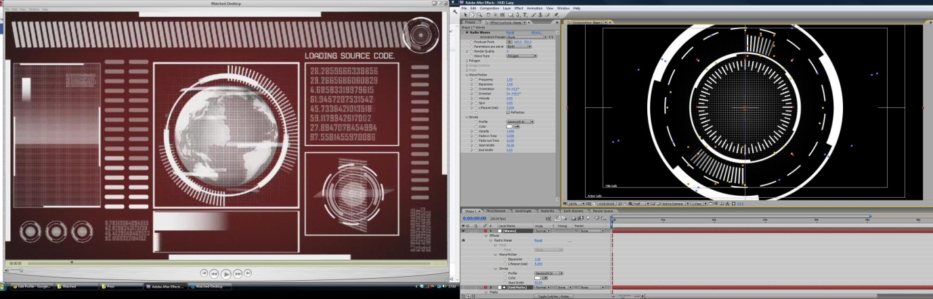

Appendix XI – Shooting Schedule

Appendix XII – Head Camera

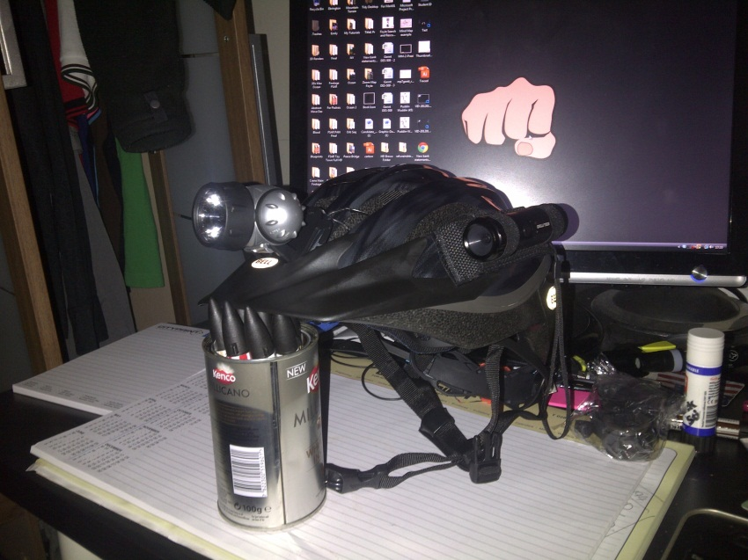

Appendix XIII – D3100 DSLR Camera

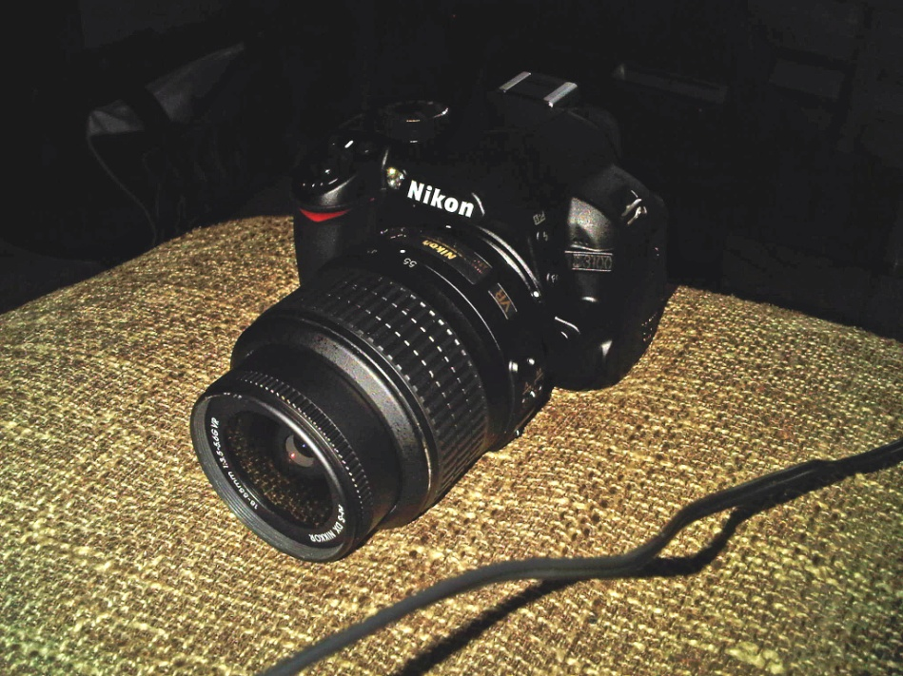

Appendix XIX - JVC Everio

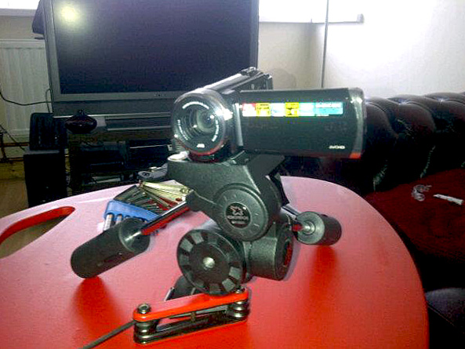

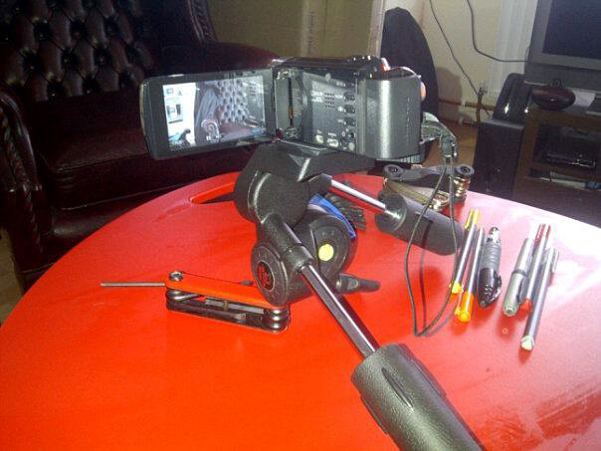

Appendix XX – Volunteer Garvin Kerr Interview Footage Altered in After Effects
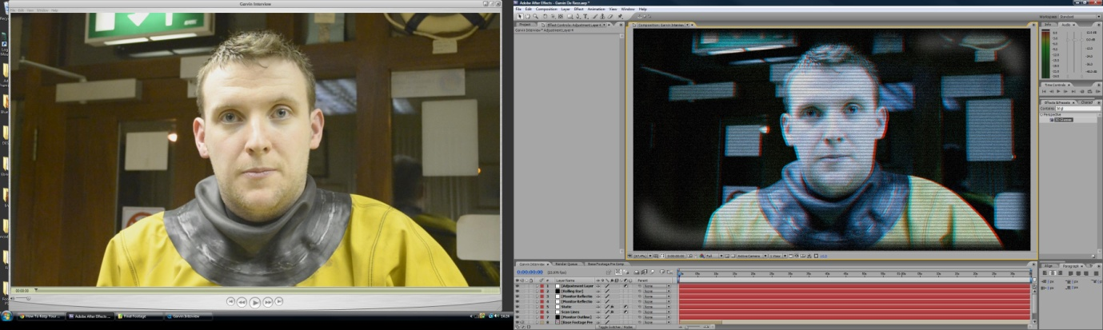

Appendix XXI - 3D Studio Max water tutorial
Water still from sequence
